January 8, 2021

Newsletter-6
Basisschool Schreuder:
een dynamische en lerende school die elk kind tot volle ontplooiing kan laten komen.

We would like to wish you many beautiful moments, health and a loving 2021!

In this Newsletter

- Important dates
- Welcome new students
- Staff changes
- Lockdown and remote education
- Half day care KleintjeZuid

Important dates

Tue 11-01 Works council (Ouderraad) meeting (online)
Mon 18-01 Start M-tests groups 8
MR meeting (online)
Tue 26-01 Walk in “Ouderkamer” is unfortunately cancelled
Fri 29-01 Newsletter 7

New Students
We can welcome 6 new students at Schreuder!
In recent weeks the following students started:
Group 1A: Nnenna Ogbonnia, Eva-Rose Mason, Andrew Mokrov
Group 1B: Loué Everts, Rudencio Menig
Group 4/5U: Valentijn Broer

We wish them all a pleasant and educational time at our school.

Staff changes

After the Christmas holidays, there have been some changes in the workforce of Basisschool Schreuder.
- Miss Roos, from group 4/5U, is now on maternity leave. Miss Charlotte van Reisen will take over her classes on Mondays and Tuesdays. Her e-mail address is: charlotte.vanreisen@amosonderwijs.nl On Wednesday to Friday, Miss Nynke will remain the 4/5U teacher. We wish Miss Roos a nice and pleasant leave!
- Juf Nian, teaching assistant in group 7, will continue her work as an assistant at the Visserschool (AMOS), where she already was working one day a week. We also wish her a lot of fun and great that she can now work at one school!
- Miss Annemieke, administrative assistant, will be working on the Atlantis (AMOS) from January. Miss Yvonne, administrative assistant, will stay at Schreuder and will work on Mondays, Tuesdays, Wednesdays and Fridays until 13:45. You can continue to ask questions about payment of parental contribution or finances to Miss Annemieke, via annemieke.proost@amosonderwijs.nl. If you use the Stadspas to pay the parental contribution, you can have a scan made by Miss Yvonne on the days mentioned.

As you know, Master Bram (gym teacher) and Miss Evelyn (group 5) have been absent for a long time. The recovery of both teachers is progressing, but very slowly. Thanks to the lockdown, there is now no need for a substitute gym teacher, but Master Justice has done a great job until the Christmas holidays. For Miss Evelyn, Master Wilko and Miss Bettina are busy teaching group 5 through online classes. We are very grateful for that.

Lockdown and remote education
The Netherlands have been in a lockdown again from Wednesday 16 December. Schools are closed, sports as a team are not possible and there is no other entertainment than in the fresh air.
Before the Christmas holidays, the Schreuder team was busy making online teaching possible. This means: arranging / preparing the online lessons, providing laptops, making an inventory of the “emergency shelter” among the parents and organizing the Noodopvang (“emergency shelter”) at school. All in all, quite a job for the whole team.
Then during the Christmas holidays there was an initiative within the city of Amsterdam to still have the children from group 8 come to school, because they are just before their advice for secondary education. After consultation with the teachers of groups 8, we made the decision to provide these students with physical education at school in the mornings, especially in the main subjects. For the afternoon the children receive homework.
All in all, during this lockdown Schreuder has 21 pupils in the Noodopvang, which is arranged together with KleintjeZuid. And every day in the mornings we have three groups (7/)8 present at school.

KleintjeZuid Half-day care
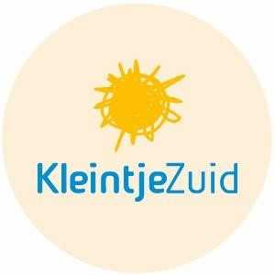
In the month of February, during one morning, it is possible to introduce your child(ren) to our half-day care KleintjeZuid Museumkwartier!
Every child is unique.
That is why we offer our children the personal care and attention they need. Our professional pedagogical staff ensure that every child feels at home in the group, makes friends, grows self-confidence and that there are new challenges every day that are good for their development.
Everything is ready to continue at this location as a recognized
pre-school (Voorschool). At pre-school, special attention is paid to preparing for primary school with the help of the 'Startblokken' educational program. This method is characterized by a development-oriented approach. The emphasis is on working with small groups. The pedagogical staff plan fun, educational activities for the children every day, during which school skills are taught in a playful way.
Has your interest been aroused and do(es) your child (ren) like to come and play (test) for a morning? Let us know via museumkwartier@kleintjezuid.nl or 020-2091330. Would you like more information about KleintjeZuid? Visit our website www.kleintjezuid.nl or follow us on Instagram.
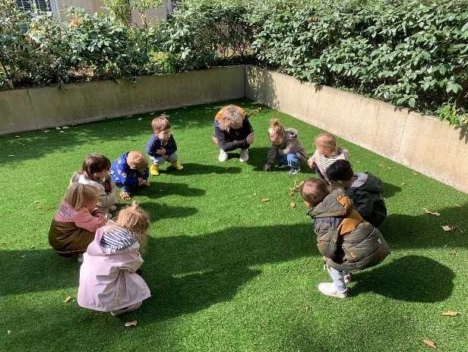
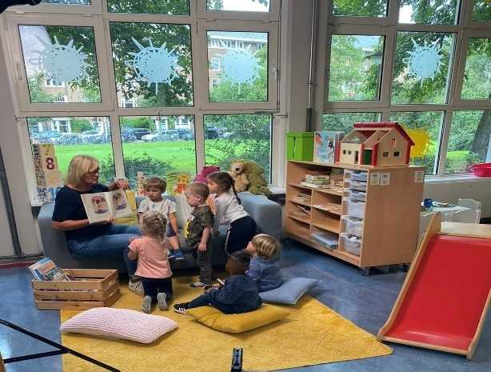
MR oudergeleding:  Frank Reef/voorzitter: frankreef@gmail.com  Bram Wijngaarden/secretaris: dwijngaa@gmail.com  Sofie de Wijs/lid: sophiedewijs@gmail.com  MR personeelsgeleding:  Ellen van de Geer (groep 7)  Jacobien Gerbrandy (groep 3)  Roos Schouw (4/5U) | Ouderraad:  Tessa Reef: voorzitter  Alle klassenouders hebben zitting in de Ouderraad  Vertrouwenspersoon AMOS:  Minke Fuijkschot: m.fuijkschot@hetabc.nl

