August 28, 2020

Newsletter 2
Basisschool Schreuder: een dynamische en lerende school die elk kind tot volle ontplooiing kan laten komen.

Team Schreuder School year 2020-2021
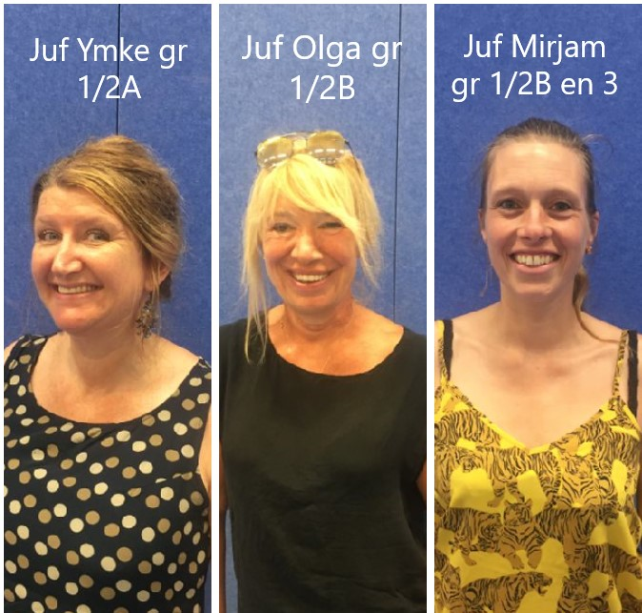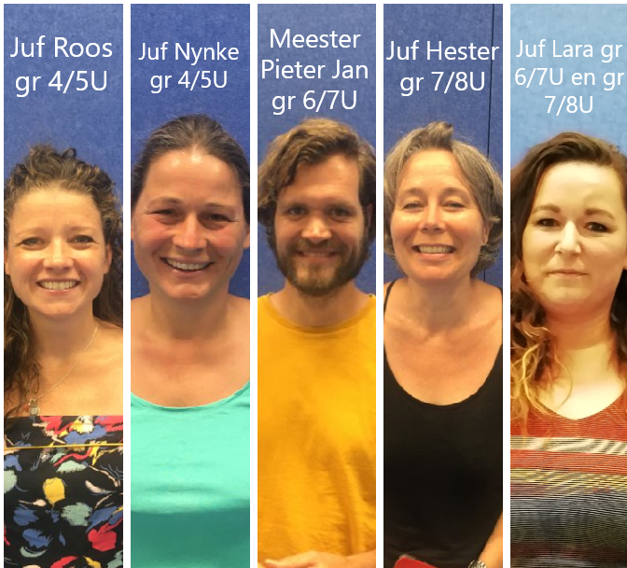
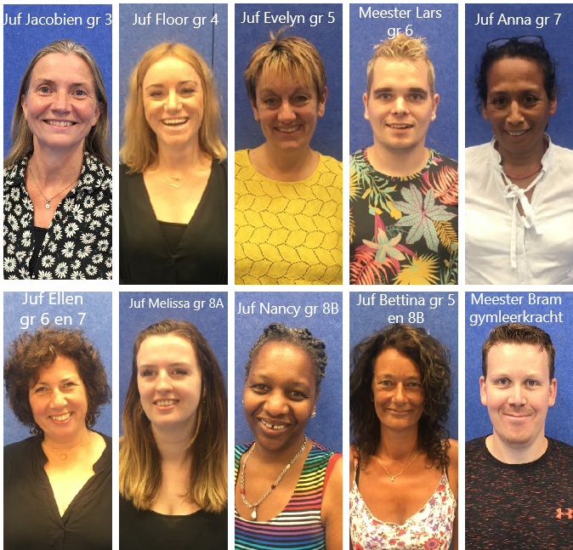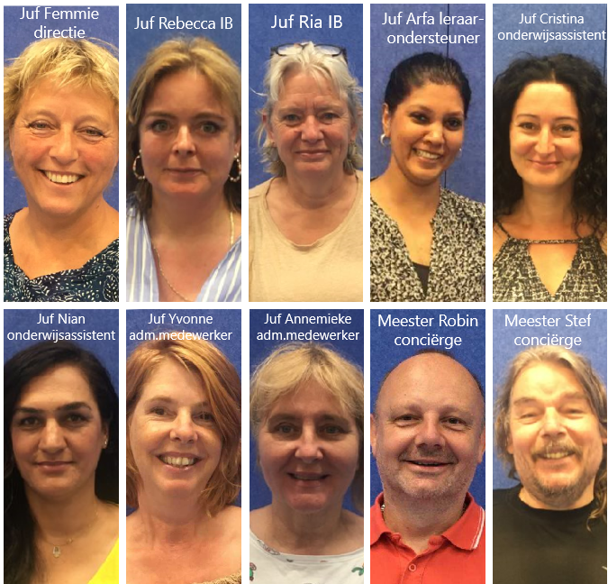

In this newsletter
• Corona measures
• School trip groups 1 to 7
• School camp groups 8
• New email address administration Schreuder
• Presentation general parents’ evening
• Information morning per group
• Start KOM conversations
• Introducing: Lucia Westerlink (TSO)
• Visit to Van Gogh Museum
• Signing up mediators
• School photographer
• Week against bullying
• Parents' room

Important dates
Ma. 31-08 Information morning groups 1/2
Works Council meeting (via Meet)
Tues. 01-09 Information morning group 3
Wed. 02-09 Information morning group 4 and 4 / 5U
Thu. 03-09 Information morning group 5 and 6/7U
Fri. 04-09 Information morning group 6 and group 7U (of 7/8U)
Mon. 07-09 Information morning group 7
MR meeting
Ma. 07-09 to School photographer
Wed. 09-09
Tue. 15-09 School trip groups 1 to 7
Wed. 16-09 to 02-10 Start-KOM conversations
Tues. 22-09 Parents' room
Wo. 23-09 to Fri. 25-09 School camp groups 8
Fr. 25-09 Newsletter-3 out

Corona measures
I would like to inform you about measures that we as a team intend to use for the coming period.
The figures on the number of corona infections are unfortunately not encouraging in Amsterdam. That's why we still don't want (groups of) parents in the school. After all, it is more difficult to keep 1.5 meters apart from each other. This means that parents cannot enter the school building when taking their child to school. Keeping your distance remains very important. However, it is possible to invite individual parents for an interview. Distance remains important, but that can be arranged easier with less persons. We will continue to let the children wash their hands at school. If your child has a cold, your child has to stay at home and get tested. If you have a cold, please do not enter our school building (in case you have an interview planned).
The question arose: my child has been tested negative but still has a cold. Is it allowed to go to school? We say NO. Your child can infect other children with its cold. The teacher can get ill by allowing sick children to attend school, with the possible consequence of no teacher at all, given the teacher shortage. We have teachers who themselves have a vulnerable home situation. They do not want to transmit sickness/colds. It is therefore possible that these team members choose to conduct also individual conversations digitally or by telephone.
So:
· No (groups of) parents in the school; even not to bring your child inside
· Individual appointments are possible in the school, if the teacher considers it possible
· Child with a cold, but tested negative? Stay home until the cold is over.

School trip groups 1 to 7
On Tuesday September 15, groups 1 to 7 will go on a school trip. A nice start of this school year!
Groups 1 to 4 (regular) go to Oud-Valkeveen by bus.
Groups 4 / 5U to 7 (also uniQ groups) will take the bus to Duinrell this year.
The guidance on this day is arranged by the class parent, in consultation with the group teacher.
The buses will depart at 8:55 AM. So make sure your child is in the classroom at 8.45 am! The supervisors and teachers wear a mouth mask in the bus, according to the guidelines.
What do the students have to bring with them? They take their fruit, drinks and lunch with them in a backpack. Lunch and drinks are the same as what they always bring to school. The school will provide some treats along the way. So do not bring candy or money to buy something! It is wise to keep an eye on the weather forecast for that day: bring a raincoat when it rains; in warm weather - summer clothes.
Groups 1 to 4 are expected back at school at 3 pm. Groups 4/5U to 7 are expected back around 3.30 pm. We hope for a fun day for everyone!

School camp groups 8
Groups 8A, 8B and 8U will go to school camp from Wednesday 23 to Friday 25 September. Because the group 8 children have been for many years in their own group, it is important for the students to get to know each other better, so they can make more friends and bond with each other. A school camp at the beginning of the school year is an excellent opportunity for positive group and school bonding. We can benefit from this bonding throughout the school year.
The group 8 children will go this year to the Paasheuvel in Vierhouten.
The parents of the group 8 students receive further information about the school camp from their group teacher.

New email address for Schreuder administration
As of today there is a new e-mail address for the Schreuder primary school administration.
The general e-mail address is: administration.schreuder@amosonderwijs.nl
You can use this address to ask your general questions, make any sickness reports (preferably by telephone!) and request information.
For questions about payments, for example the parental contribution, please email: annemieke.proost@amosonderwijs.nl
For questions about student administration, registrations, please email: yvonne.verhage@amosonderwijs.nl

Presentation General Parents’ Evening
Thursday 27 August an email was sent to all parents containing a link to the presentation for the general parents' evening. The video provides information about general issues of the school, such as the food and drink policy, the Peaceful School and parental involvement.
If you have any questions, there will be on Thursday 3 September the possibility to get in touch with me and other interested parents via a livestream. Please send an answer in response to my email, then I will add you and you will receive an invitation for Question Time.

Information morning per group
In the first weeks of September we hold an INFORMATIONMORNING for each group. See the schedule in Parnassys and above under 'Important dates'.
Due to the corona measures, no groups of parents can enter the school. That is why the teachers will each make a presentation or video recording in their own way in which they tell what the students of the group will learn in this school year. On the planned information morning you will be invited by the teacher to be present via a live stream to ask questions or ask for clarification from the teacher. This will take place on the indicated date from 9 a.m. to 10 a.m.
Extra information for groups 3 to 8:
The “leerlijnen” (goals per subject area per grade) can be found on the private section of the website: www.instituutschreuder.nl -> About the school -> Documents. In the mail of this Newsletter I will send you the password to log in.
The purpose of this information morning is to involve you more as a parent in the school and the goals that are being worked on with your child.
In this way, parents can also come into contact with each other. Last year, this method of information provision turned out to be very successful! You will receive a separate invitation from the group teacher for the information morning of your own group. We hope for a high participation!
Start-KOM interviews
In the coming days you will receive information via the information mornings about what your son / daughter will learn this school year.
After that you can sign up for a Start-KOM interview. KOM stands for: Child-Parent-Teacher. This conversation is about getting to know each other, expressing wishes and expectations to each other, going through the agreements of the previous school year and also making agreements about the manner and frequency of communication between home and school.
The school holds two 'fixed' meeting moments with parent and child: the Start / KOM meeting in October and the KOM meeting in February (based on the report). In addition, a parent can choose to be informed in the meantime. This can be done by:
-an e-mail (initiative lies with the parent!),
-An update by telephone
-and / or an extra conversation.
During the Start / KOM meeting you make agreements about this with the teacher. (Note: You will be informed by the teacher anyway if something striking is going on.) If something happens in the home situation that affects your child, we would like to be informed.
This means that we do not hold report interviews at the end of the school year (with some exceptions). These have actually been moved to the beginning of the school year. But your son / daughter will receive the school report at the end of the school year. The teacher will send you an email when you can sign up for the start KOM interview.

Introducing: Lucia Westerlink (TSO)
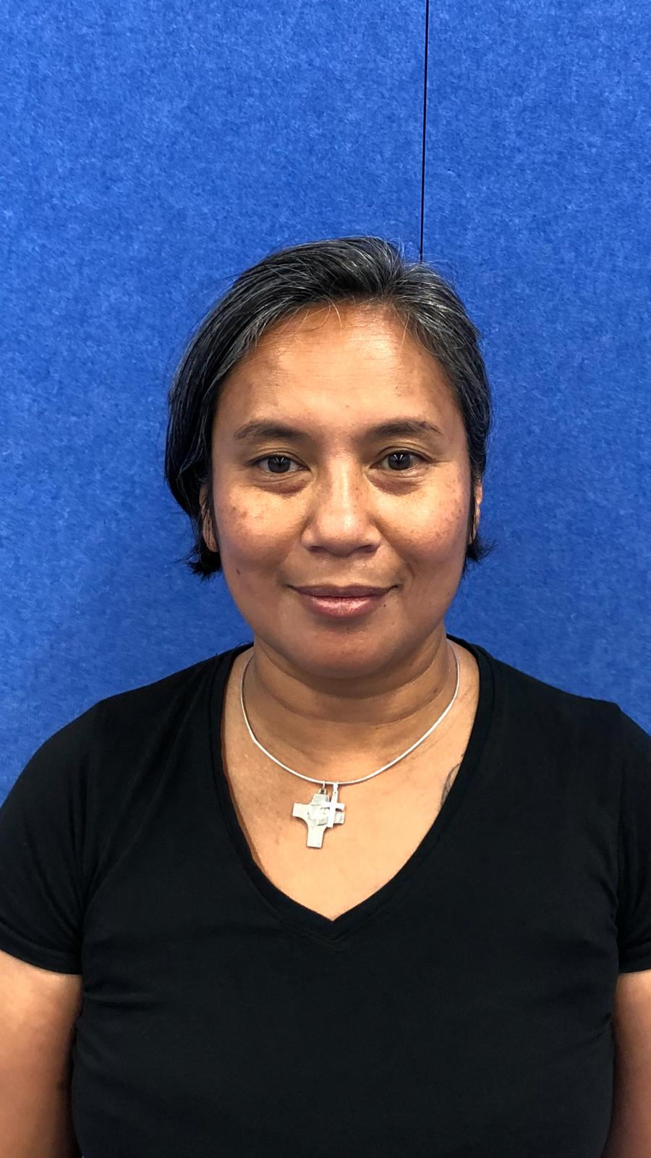
My name is Lucia Westerlink, TSO Coordinator of Basisschool Schreuder, I would like to introduce myself. I am 48 years old, married and the mother of 2 children, a son of 19 and a daughter of 14. Both went to Institute Schreuder. From my company Your Facilities, the school hires me to provide the TSO. We have been doing this, together with my team of 2 men and 9 women, with great pleasure for 7 years now. Our TSO team is trained every year by our parent and child supervisor, after which we plan an intervision meeting 3 times a year. To see where we can improve ourselves.
The start of the year was off to a good start with all our children. We look forward to a great school year in which we want to offer our children a safe and pleasant TSO.
With warm regards, Lucia Westerlink, TSO Coordinator Basisschool Schreuder

Visit to the Van Gogh Museum
Groups 7, 8A and 8B will be visiting the Van Gogh Museum on Monday (August 31) and Wednesday (September 2), just across the street. They will try out a lesson from the museum there. Schreuder primary school has signed up at the museum for the 'try-out' of curricula for primary education. Of course it is not an obligation and it must fit into the school's curriculum.
But in general the lessons are of high quality and of course our students learn a lot from them!

Applying for mediator
Since the introduction of the “Peaceful School” at Schreuder, we also work with mediators during the short break and lunch break. A mediator can help resolve a conflict between 2 students. It's not about a fight. All students learn at the Peaceful School what the difference is between a conflict and a fight.
Pupils from the upper classes (groups 7 and 8) can apply for the role of mediator. Ultimately, a choice is made of students who can meet the following profile:
• can listen well
• wanting the best for both students who are in the conflict (win-win situation)
• carry out the steps according to the step-by-step plan
A mediator never works alone. There are always 2 mediators on the square. A mediator is never used if:
-there is a fight,
-it concerns more than 2 students,
-in bullying.
In all these cases the teacher is immediately called in.
If your son / daughter wants to participate as a mediator, he / she will receive training for this. This is provided by Miss Nancy (group 8B) and Miss Lucia (TSO coordinator). Obviously, permission will be requested from the parents.
By working with the ‘Peaceful School’, we will also use mediators during the children's breaks.

School Photographer
On Monday 7 to Wednesday 9 September, the School Photographer will come for all class photos and individual photos. These photos are taken during school hours. In addition, there is the possibility to have a photo taken of brothers and sisters together.

The photographer's name is Esther Quelle. Quality is paramount for this photographer.
To guarantee quality over quantity, it does not work via digital orders, but simply in the older way, with also payments that are submitted to the teacher via the enclosed envelope. For an impression, please visit: http://www.estherquelle.com/

Week against bullying
It really shouldn't be necessary: ​​a week of attention to combating bullying. At Schreuder we noticed that working with the Peaceful School's curriculum has a very preventive effect and that bullying is often prevented as a result.
It has been agreed in the student council of AMOS that we will nevertheless bring the prevention of bullying to the attention every year in the week from 21 to 25 September. We do this together with the Peaceful School curriculum.
A safe atmosphere in the classroom creates feelings of confidence and tranquility. It creates a situation in which growth and learning are possible.
It is also important that children learn to see the difference between teasing and bullying. There will also be extensive attention for this in class. In this way we ensure a safe and positive learning climate in the school.

Lost & found objects (found before the summer holidays)
In the team room there are 2 garbage bags with found jackets, bags, shoes, gloves, scarves, etc. If you have lost an item before the summer vacation, you have until Friday 11 September to search in the 2 garbage bags. Then we take the bags to the clothing container.
Parents’ room
Dear Parents,
The school is up and running again. Everyone is starting to find their place in the new group and the renovated building. Due to corona, there is unfortunately no room for parent meetings within the school building. As a school we started with block 1 "We belong together" of the Peaceful School. This first theme is more appropriate than ever!
The planned parents' room on September 22 will be given a different shape, but will continue!
The target:
We belong together! Get to know each other as parents / guardians and organize a picnic together. Take time for each other and discuss the commitment of the Peaceful School.
Location:
Museumplein. We leave at 8.45 am from the schoolyard towards the Museumplein. I (Mirjam Kane) have a shopping cart with me and I can be recognized by the green Schreuder vest.
For whom:
Parents and guardians of the school! Mirjam Kane organizes this from the school and will also represent the school.
What:
The school provides a cup of coffee or tea. I want to ask the parents to bring some treats to hand out and a picnic rug to sit on so that we can guarantee the 1.5 meters.
Please sign up by email: mirjam.kane@amosonderwijs.nl so that we can take the amount of coffee and tea into account.
I hope to see you September 22 at 8.45 am in the square!

Kind regards, Mirjam Kane, Parent liaison officer / VVE and group 1& 2 coordinator.

MR parental section:  Frank Reef: chairman  Bram Wijngaarden: secretary  MR staff section:  Ellen van de Geer (group 7)  Jacobien Gerbrandy (group 3) | Parents Council:  Tessa Reef: chairman  All class parents are on the Parents Council.  Confidential advisor AMOS:  Minke Fuijkschot: m.fuijkschot@hetabc.nl

